|  |  |
| --- | --- |
| **Server & Cloud Security**  Diploma in CSF/IT  Oct 2022 | Week 4 |
| Tutorial |
| **Cloud Security Basics - Guide** | |

1. Briefly discuss the key features / advantages of SaaS model.

|  |
| --- |
| * Offers off-the-shelf convenience and ease of use. * Provides flexibility due to access across devices and geographies. * As a subscription-based model, it allows for budgeting and planning ahead. * Self-provisioning (ability to add users as needed). * No maintenance or installation requirements. * You don’t pay for the hardware that runs the application. * You don’t need to worry about maintenance or licensing fees. * Nothing to install and no support worries. |

1. Briefly discuss the key features / advantages of PaaS model.

|  |
| --- |
| * PaaS provides a platform with tools to test, develop, and host applications in the same environment. * Enables organizations to focus on development without having to worry about underlying infrastructure. * Providers manage security, operating systems, server software and backups. * Facilitates collaborative work even if teams work remotely. |

1. Briefly discuss the key features / advantages of IaaS model.

|  |
| --- |
| * Instead of purchasing hardware outright, users pay for IaaS on demand. * Infrastructure is scalable depending on processing and storage needs. * Saves enterprises the costs of buying and maintaining their own hardware. * Because data is on the cloud, there can be no single point of failure. * Enables the virtualization of administrative tasks, freeing up time for other work. |

1. Referring to the “Division of Responsibility” diagram by Microsoft, discuss the differences in responsibilities when your workload is hosted on Software as a Service (SaaS), Platform as a Service (PaaS), Infrastructure as a Service (IaaS), or in an on-premises datacenter.

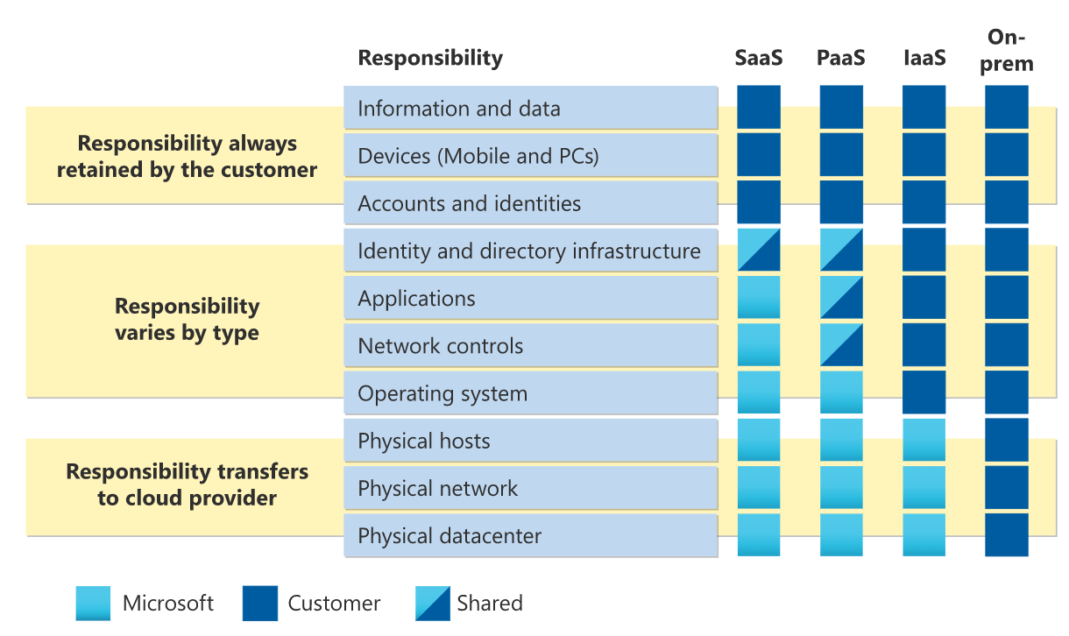

|  |
| --- |
| * In an on-premises datacenter, you own the whole stack. As you move to the cloud some responsibilities transfer to the cloud service provider. * For all cloud deployment types, you own your data and identities. * You are also responsible for protecting the security of the cloud components you control depends on the service type (SaaS, PaaS or IaaS). * Regardless of the type of deployment, the following responsibilities are always retained by you: * Data * Endpoints * Account * Access management |

- The End -